
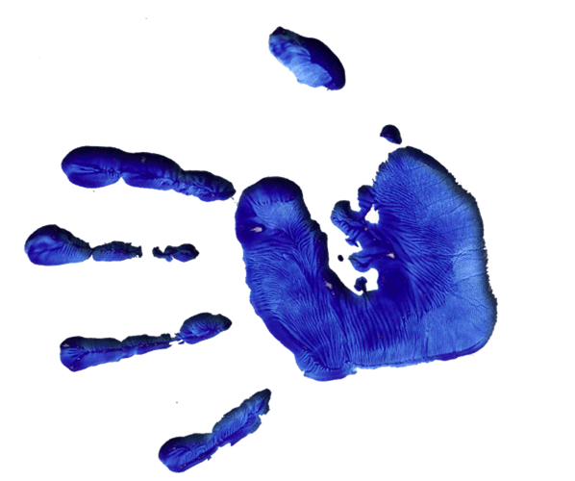

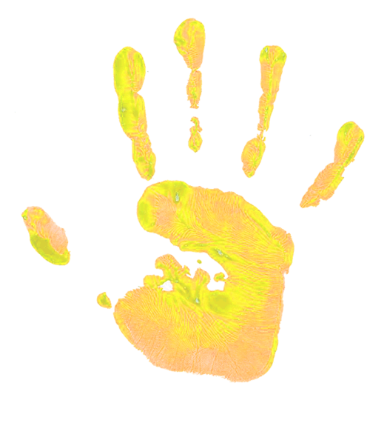
HELPING HANDS BREAKFAST AND AFTERSCHOOL CLUB
Holy name school

POLICIES AND PROCEDURES

Below is a list of our policies and procedures so that you may understand how Helping Hands is operated.

* Your Child
* Admissions Policy
* Booking Procedure
* Fees
* Payment Procedure
* Cancellations
* Collections/signing in and out
* Illness & Injuries
* Medication
* Equal Opportunities
* Safeguarding Policy
* Complaints & Comments
* Behavior Policy
*parents contract
*Ofsted registration number EY403842

Contact details
Samantha 07904942281
Michelle 07737535967
Club: 07806774275
Email: helpinghands.childcare@hotmail.com

Your Child

Events in your child's life away from Helping Hands will probably effect his / her behavior at the club. Please keep us informed so that we may be sensitive to your child's needs.

Helping Hands would like to work as a team with the school and your family so that we can provide the best environment for your child's growth and development.

If there is anything in any of these areas that we can help with, please be assured that you can discuss them with complete confidence.

Admissions Policy

Helping Hands out of school Club is open to every family that attends holy name school

The waiting list is operated on a first come, first served basis.

All children must be of school age. (3+) When all the places are filled, a waiting list will be established with the following priority order:

1. Siblings of children already attending
2. Existing users who require the greatest number of sessions each week during term time.

Emergency admissions will be at the discretion of the Manager/Senior member of staff on duty .

Booking Procedure

A form MUST be completed to register your child BEFORE a booking can be made. These are available from the staff.

Bookings can be made at any time. Places are subject to availability and are allocated in accordance with our admissions policy.

Places are limited.
Please book places in advance where possible to assist us with staffing arrangements

FEES

£8.50 per session morning 7.30 am-8.45am school
£11.00 per session after school club 3.15pm -5.45pm

Please note, if collection of your child runs into the next hour, a fee of £10.00 per 15 minutes will be charged

Payment Procedure

All payments to be paid in advance at the beginning of each month. Payment method can be paid cash , childcare vouchers or direct into bank Co operative business bank sort code 089250 account number 68616850

Cancellations

Cancellation fees are as follows:
More than 7 days notice - no charge
Less than 7 days notice - half session fees will be charged
Less than 48 hours notice - full session fees will be charged
Two weeks holiday per year may be taken, when a retainer fee of half the usual rate is payable per week.

Please Note: The above facility is available for temporary cancellations e.g. to help with holidays and short absences.
THIS POLICY IS STRICTLY ADHERED TO

Arrival at Helping Hands

It is the responsibility of the parent/carer to ensure that upon their child’s arrival at Helping Hands, they are handed over to a member of staff in order for their attendance to be registered. Helping Hands are not responsible for any children that are left on school premises without this procedure taking place.

Collections.

COLLECTION FROM HELPING HANDS

If, for any reason, somebody different is collecting your child from Helping Hands, please inform the Club Leaders, as no child will be allowed to leave the premises without confirmation from the parent/carer and password supplied.

Illness & Injuries

A sick child should be kept at home, both for their own sake and that of others. Children must not attend the club if they would normally be regarded as unfit for school due to the illness/injury. Please inform us about the nature of any illness, particularly if it is a communicable disease.

If your child becomes ill while he/she is at Helping Hands we will contact you and ask you to collect your child. If a child complains of illness, which does not impair their functioning, you will be notified when the child is collected. In the event of minor injuries a qualified member of staff will administer first aid. You will be informed of the incident when you come to pick up your child and you will be asked to sign the accident report book.

If your child is more seriously injured, we will make every effort to contact you as soon as possible. If necessary, we may call an ambulance and have your child taken to hospital in the company of a staff member. In any of the above situations, if you are unavailable, we will contact the people listed on your registration form. If there is any form of medical treatment, which you would NOT wish your child to have, please ensure that it is written on your registration form and that the Club Leaders are informed.

Medication

If your child needs to take medication whilst at Helping Hands, you should bring it directly to the staff at the beginning of the session and a medication form will be completed.

Children MUST NOT leave medication in their bags.

Please ensure that the medication is clearly labelled with your child's name and the dosage instructions.
.

Asthma inhalers again must be clearly labelled, with the child's name and the dosage instructions and used only as necessary

Equal Opportunities

All children will be respected for their individuality and their potential recognised, valued and nurtured. Activities and the use of play equipment offer children opportunities to develop in an environment free from prejudice and discrimination. Appropriate opportunities will be given to children to explore, acknowledge and value similarities and differences between themselves and others in the areas of gender, race, culture, religion, language and abilities. In order to ensure these principles are adhered to, the club will practice the following:

1. Admission will be in accordance with the Admissions Policy.
2. Registration will ensure that children's names are accurately recorded and pronounced.
3. Discriminatory behaviour/remarks are unacceptable in Helping Hands Club and will be treated seriously.
The Response will aim to be sensitive to the feelings of the victim and to help those responsible to understand and overcome their prejudices.
4. Racist symbols, badges and insignia in any form are forbidden in the club.
5. When appointing staff, Helping Hands Club will appoint the best person for each job and will treat fairly all applicants for jobs and all those appointed. Commitment to implementing the Club's Equal Opportunities Policy will form part of the job description for all workers.
6. All staff must be aware of possible cultural assumptions and bias within their own attitudes.
7. All staff must be aware of the language and dialect spoken by children and their families.
8. Resources will be chosen to give children a balanced view of the world and an appreciation of the rich diversity of our multi-racial society.
Material will be selected to help children develop their self-respect and to respect other people by avoiding stereotypes and derogatory pictures or messages about any group of people.

Safeguarding Policy

Helping Hands has a duty to children and parents to ensure the safety and protection of children from abuse. We intend to create an environment in which children are safe from, and in which any suspicion of, abuse is promptly and appropriately responded to. In order to achieve this we will:

Ensure all staff are police checked have an up to date enhanced DBS certificate.

Where adults who have not been police checked have contact with children, we will ensure that they are never left unattended or in situations where abuse/allegations could occur.

Action will be taken if staff find reason to believe that a child is being abused in any form.

Photographs will only be taken of children with their parents’ permission. Only the club camera will be used to take photographs of children at the club, except with permission of the manager. Neither staff nor children may use their phones to take photographs at the club. Parents are also not permitted to use their mobile phone’s whilst in club.

Helping Hands has a duty to report incidents of concern to the Local Authority for them to investigate.

Staff are trained to identify radicalisation and extremism and FGM.

A COMPREHENSIVE COPY OF THIS POLICY IS AVAILABLE AT THE CLUB

Helping hands a fully compliant to the general data protection regulation (GDPR)

Complaints & Comments

If, at any time, you are not satisfied, have concerns about, or have any comments to make relating to any aspect of the Club, please put your comment/complaint in writing and address it to a member of the Management Team .

The matter will be dealt with promptly and the outcome discussed with you.

You also have the right to approach OFSTED, the Registration Authority, direct. OFSTED can be contacted on 0300 1231231 or you can visit their website
A complaint book is also available for you to use.
Behaviour Policy

IMPORTANT - PLEASE READ CAREFULLY

Helping Hands aims to create a happy and relaxed atmosphere in which all children attending can play, enjoy the activities on offer and express themselves without fear of intimidation, harassment or physical or verbal abuse.

Helping Hands is a place where children are allowed to be loud, messy and boisterous at appropriate times as long as they are not putting themselves or anyone else in danger or discomfort.

Children will be involved in establishing rules for behaviour at the club.

We do not use physical punishment in any form.

We also do not use any harsh methods of dealing with difficult behaviour such as shouting or threatening.

No action likely to frighten or cause humiliation will be used.

We strive to promote behaviour that encourages respect for each individual, co-operation with each other and opportunities for play and adventure within a safe and caring environment.

We have a comprehensive Behaviour Management Policy that is available for parents/carers to read and, if necessary, discuss with us. Admissions will be at the discretion of the Manager/Senior member of staff on duty.

Outdoor Play

At Helping Hands we have full access to the playground, and as part of our emphasis on the EYFS guidelines we will be encouraging outdoor activities and games.

OFSTED REGISTRATION EY403842

Helping hands booking form

Name of child ………………………… Date of birth ………………… Age ……………………….
Gender…………….
Address………………………………..…………………………………………………………………
………………………………………………………..Post Code ……………………………………..
Telephone No. (Home …………………………………Email address……………………………..

1. Emergency contact No and Name ………………………………………………………….........
2. Emergency contact No and Name ………………………………………………………………..
(Please supply emergency telephone No’s, name of contact, plus relationship to child)
Name of Parent/s with Parental responsibility………………………………………………………
Address (if different to above) ………………………………………………………………………...
Name /s of Legal Contact ……………………………………………………………………………..
Religious and ethnic origin……….. …………………………………………………………………..
Name, address and telephone number of doctor ……………………………………………………………………………………………………………
……………………………………………………………………………………………………………
Any other details relevant to your child (e.g. special, diet, allergy, medication, etc) …………………………………………………………………………………………………………… …………………..………………………………………………………………………………………..
Child’s class or years……..………………. Teachers Name … ………………………………….
Specimen of signature (Parent/s)………………………….………………………………………….
Specimen of collector/s ………………………..... ………………………………….........................
Password for use in an emergency ………….. …………………………………………………......

SESSIONS REQUIRED (Please circle)

BREAKFAST CLUB MON TUES WEDS THURS FRI
(7.30am – 8.45amTerm time only)

AFTER SCHOOL CLUB MON TUES WEDS THURS FRID
(3.15pm – 5.45pm - Term time only)

Consent requests – Please read the consent requests below and mark them as appropriate. * (Please delete as appropriate)

* I consent / I do not consent to my child undergoing any emergency medical treatment necessary during the running of the club.

* I consent / do not consent the staff to sign any written form of consent required by the hospital authorities if the delay in getting my signature is considered by the doctor to endanger my child’s health and safety.

Should my child need to take medication which has been prescribed by our GP,
* I consent / do not consent, the staff to supervise this medication as prescribed on my instructions only.

During some of the routine activities of the club photographs or recordings may be taken, these will be used for display work within the club and as evidence for Ofsted and Early Years and training purposes, they may be used on the our website and social media we won’t use child name. * I consent / I do not consent for the staff to take photographs/recordings of my child as part of the daily activities at the club.

Date placement to commence ……………………………………………………………………..

Fees must be paid monthly in advance.

Payment should be made by either cash, childcare vouchers or bank

I hereby undertake to maintain regular and up to date payments of Out of School Club Fees. I understand that to terminate this agreement, four weeks notice or payment in lieu of notice must be given, failure to comply with this may result in loss of placement and legal recovery of amounts outstanding.

Signed ………………………………… (Parent/Guardian) Date ……………………………

When completed, please return to:-

Helping hands breakfast and afterschool club

All information is treated in confidence; the information on this application form will be under the (GDPR)

Helping hands
Contract with Parents

Child’s name
Parent or carer’s name

- I consent for my child to attend helping hands out of school club. I understand that the club has policies and procedures (which are available for reference at the club), and that there are expectations and obligations relating both to the club and to myself and my child, and I agree to abide by them.
- I understand that helping hands is a play setting and that whilst my child is there Out of School Club is legally responsible for him/her.
- My child will be provided with a snack and drink whilst at the club unless otherwise requested.
- Once my child arrives at Out of School Club he/she will be in the care of Out of School Club until collected and signed out by an authorised person.
- I will notify the club before the start of the session if I am collecting my child from school on a day that he/she is booked to attend the club. I understand that I will be charged for the booked session.
- I will book my child into the club on a monthly in advance basis and will pay promptly for all booked sessions whether my child attends or not (eg due to illness or holidays), unless I have made other arrangements with the manager.
- It is my responsibility to keep the club manager informed of any alterations to the information regarding my child (eg contact details, medical conditions, etc).
- I accept that my child may take part in messy activities while at Out of School Club. I understand that I can provide my child with appropriate clothing to accommodate this if I wish.
- Out of School Club closes at 5.45pm. If, due to unforeseen circumstances, I am going to be late, I will contact the manager/deputy as soon as possible.
- If I do not collect my child by 5.45pm I will pay a charge of £10.00 per quarter of an hour to cover the costs of the staff who are legally required to supervise my child.
- If I do not collect my child by 6.30pm, and the club has been unable to reach me or any of my emergency contacts, I understand that Out of School Club will follow its Uncollected Children Policy and contact Social Care.
- Whilst Out of School Club tries to ensure the safety and security of items, I understand that it cannot be held responsible for loss or damage to my child’s property whilst at the Club.
- I have read the club’s Behaviour Management Policy and agree to its terms and appreciate that in some circumstances it may be necessary to exclude my child from the club, and I will pay for any missed sessions unless otherwise agreed with the manager.
- If there are any accidents or incidents at Out of School Club involving my child, I will be informed.
- If my child has an accident at the club, he/she will be treated by a qualified first aider and I will be informed as soon as possible. If my child needs urgent medical treatment and I am unavailable, a member of staff from Out of School Club will sign any consent forms necessary for treatment on my behalf, as stated on the club’s Medical Form.
- Information held by Out of School Club regarding my child will be treated as confidential. However, in certain circumstances, for example if there are child protection concerns, I understand that the club has a legal duty to pass certain information on to other agencies, including Police, Social Care and health care professionals.
- I understand that aggressive and abusive behaviour towards staff will not be toleratedI have read and understood the above terms and conditions and I agree to abide by them.
Signature: Date

